Renju lesson on March 28, 2002

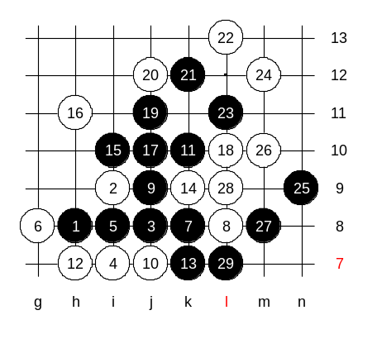
Hello everyone! Welcome to Online Renju Class. Now, let me remind you, dear students, that we will all speak in one language during class. All the other languages can be used in whispers. Today we will pick another 4th move for our study. Do you want to suggest the 4th move or I shall pick one? I play i7 according to the decision of most people here. I guess most of you know the winning 5th move at i8. Is here anyone who doesnt know black win here? say "me". Well, thats good. Since we have some people who do not know win, we review it first. 12th - Which side first?
Who is ready to show black win, say "me", please. Please, tunnet99. Very good!

The other 12th move will be the medium homework. :)

Black has two possible alternative 5th moves - i6 and h7. White has three possible continuations here. Which are they? Move g8 is too weak and loses fast.
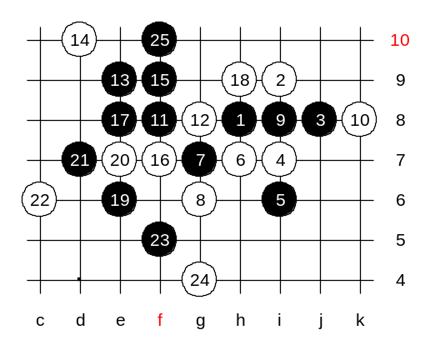
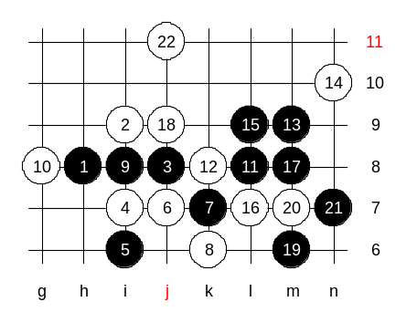
So, we need to consider about 6-h7(j7), 6-h9(j9) and 6-i8. Move 6-i8 is the most boring and passive, but perhaps the strongest. OK, we begin with losing moves, and consider the edge influence. Move 6-h7, is close to the center, but that actually turns out to be a big weakness. Move 7-g7 goes well with this 6th move. The 8-g6 is forced. Other 8th moves are much weaker. By the 15th move black has sure win position. Lets try an example variant. By the 25th move the game is over.

We change the 6th move. Looks same, but different distance from edge.

As a result, black failed the attack.
This problem puzzled me in the past, and forced me to seek for another win method.

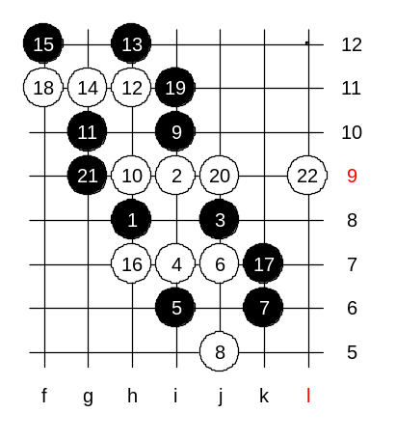
Indeed, I chose k6 to be the starting move.
This is a famous pattern that is called a "ladder". It grows like this. It was shown in one of the articles, written by Sagara. Too bad, there is an easy 3x3.

But this Ladder is good as long as black remembers to "turn off the path" before the 15th move.

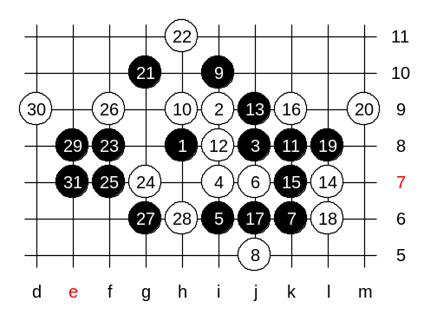
The path that I show you, turns off from main road in 11th move and leads to win.
There are two main variants, 12-i8 and 12-L8. Which one comes first?
Ok we choose i8. At the 20th move, we have two paths again. OK, we first check upper one. Move 21- a powerful connection move. I checked all blocks here, and all lead to black win. Move 23, a VCF threat. By the 31st move the game is over and black wins.
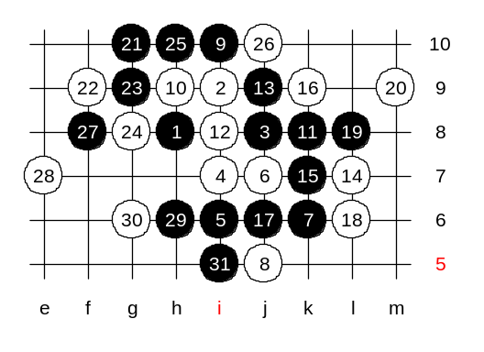

Another 22, black still wins.

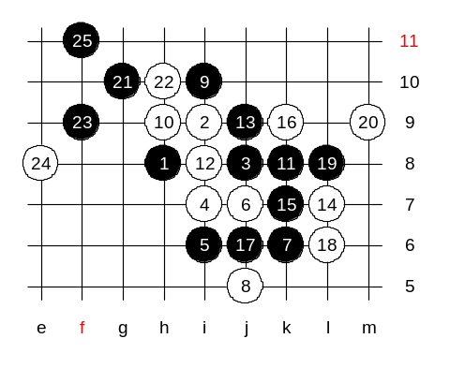
Move h10 is also quite tough, and many of you may easily miss the win here. Move 24-e8 is forced, otherwise black will stretch out to the left side space and win fast. Move 25-f11 is a beautiful ending move. 26-h6 is forced. And then anyone can win in upper side. :) Remember about such 25th move - it did not create many lines, but it was powerful because of its connections.

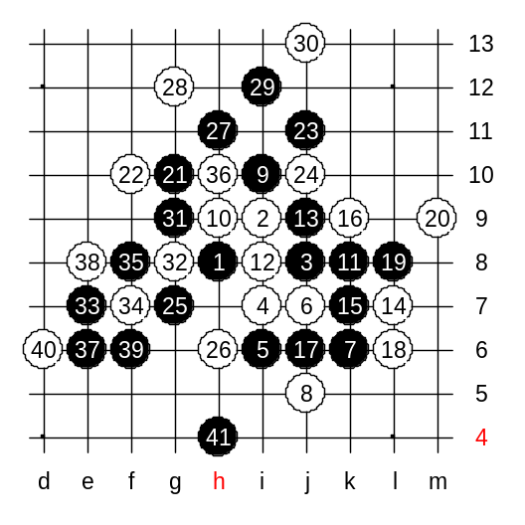
The last 22nd move, the strongest perhaps. How many of you know black win here? Tunnet knows, let him show and explain. Well done tunnet!

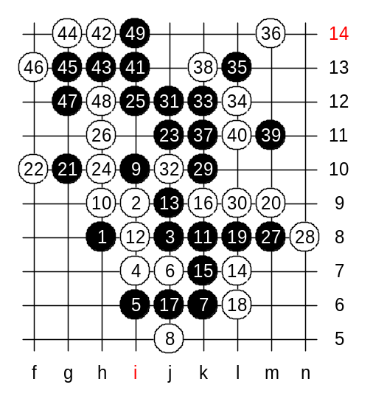
Only this 24th move is a bit special and needs different style because of missing connection. Who can show win here? Tunnet, please.
Tunnet99: “now comes i12.. Black can't play h11 and i12 ..cause then no win I think. Fours - cause then we get such help as 29... . The 33 - Now very strong attack, White can't play h12, or black win at right side. Move 37 - another strong inside devolop :)”

Well done tunnet99!!

